CHAPTER 5: Chemical reactions

Worksheet 5.5

Metal displacement
Answers

Growing metal crystals
1. A shiny copper wire was suspended in a test tube containing a solution of silver nitrate. Over time, shiny silvery coloured crystals grew on the surface of the copper wire. The experiment was repeated with a shiny magnesium wire in place of the copper wire. Once again silvery crystals grew on the wire surface. However, the crystals grew at a faster rate.
(a) Identify the silvery crystals that formed in each experiment.
Silver forms in both experiments.

(b) Write word equations for each reaction.
Copper + silver nitrate → silver + copper nitrate
Magnesium + silver nitrate → silver + magnesium nitrate

(c) Explain why the crystals grew faster in the second experiment.
Magnesium is a more active metal than copper and reacts more rapidly.

The activity series of metals
2. The following table shows the activity series of metals.

Li | K | Na | Ca | Mg | Al | Mn | Cr | Zn | Fe | Ni | Sn | Pb | H | Cu | Hg | Ag | Au | Pt

The photo shows zinc reacting with hydrochloric acid.
Photo: Public domain | 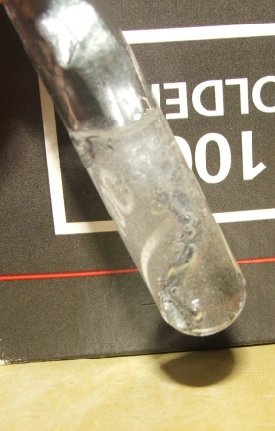 | (a) Identify the gas released in the reaction.  Hydrogen  (b) Write a word equation for the reaction.  Zinc + hydrochloric acid → hydrogen + zinc chloride  (c) Explain why this reaction is an example of a  displacement reaction.  The zinc displaces hydrogen from the solution.  (d) Use the activity series to identify:  (i) metals that will not react with hydrochloric  acid  Cu; Hg; Ag; Au; Pt  (ii) the metal that will react most rapidly with the  acid solution.  Li (lithium)

